

FACULTY OF INFORMATION AND COMMUNICATION
TECHNOLOGY

BITU 3923
WORKSHOP II
SUPERVISION LOGBOOK

Student Name | MUHAMMAD AIMAN AFIQ BIN ZAINAL FITRI
Matric No. | B032420066 | Sem / Session |  | 1-2025/2026
Programme | BITS | Group No. |  | 12
E-mail | B032420066@student.utem.edu.my |  | Contact No. | 60103025677
Project Title | IPetro RBI Automation: AI & OCR-Driven Inspection Planning from Equipment Drawings
Supervisor Name | DR. NOR HAFEIZAH HASSAN

Week: 3 |  | Date: 28 Oct 2025
Task | Problems/Solutions |  | Evidence
- Collected the requirements and data needed from IPETRO mentorship through online meetings and WhatsApp group.  - Do some research about API 580 and API 581.  - Find the approaches to extract data from PDF into Excel spreadsheet.  - Prepare the proposal based on what we’ve agreed with our supervisor, Dr. Nor Hafeizah.  - List out the modules that might be needed for our project. | - I’ve joined IPETRO WhatsApp group.  - I’ve been assigned to find some information regarding API580 and how it relates to our project  - Our first draft of our proposal was submitted to our supervisor and any mistakes that needed adjustments were done.  - I created 8 possible modules that might be needed for the project. The modules were discussed with our supervisor on their eligibility. |  | 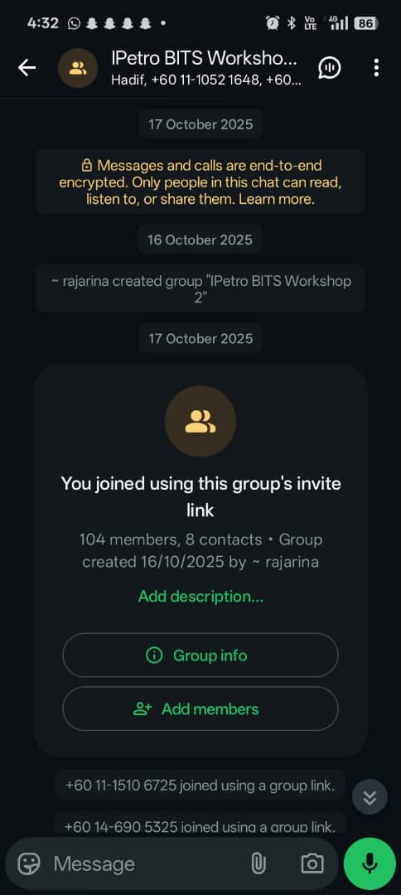  Api 580  Module Recommendation
Supervisor’s feedback |  | Response to supervision
Student’s Signature:

LOGBOOK APPROVAL BY WORKSHOP II SUPERVISOR

PROGRESS 1

Feedback:

(Name/Signature /Official Stamp) (Date)

PROGRESS 2

Feedback:

(Name/Signature /Official Stamp) (Date)

PROGRESS 3

Feedback:

(Name/Signature /Official Stamp) (Date)

